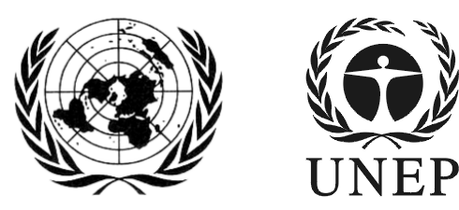 | SAICM/ICCM.5/Bureau.2/7
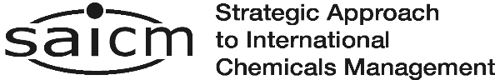 |  | Distr.: General  22 November 2016  English only
Second meeting of the Bureau of the
International Conference on Chemicals Management for its fifth session
Sao Paulo, Brazil
7-8 December 2016
Item 5 (b) (iv) of the provisional agenda*
Intersessional process for considering SAICM and the sound management of chemicals and waste beyond 2020: First meeting of the intersessional process (7-9 February 2017)

Draft document list for the first meeting of the intersessional process on SAICM and the sound management of chemicals and waste beyond 2020

Note by the secretariat
The secretariat has the honour to circulate in the annex to the present note a draft list of documents to be prepared for the first meeting of the intersessional process on SAICM and the sound management of chemicals and waste beyond 2020. The Bureau may wish to provide feedback to the secretariat on the draft document list.

ANNEX

Draft document list for the first meeting of the intersessional process on SAICM and the sound management of chemicals and waste beyond 2020
Meeting Documents
- Provisional agenda
- Annotated provisional agenda
- Scenario note
- Interim report of the independent evaluation of the Strategic Approach for 2006-2015
- Proposed overall timeline for the intersessional process
Information Documents
- Update on Strategic Approach progress reporting for 2014 – 2016
- Reviewing the Strategic Approach indicators of progress
- Information note on the Global Chemicals Outlook II
- Information note from the WHO on implementation of World Health Assembly Resolution 69.4 on The role of the health sector in the Strategic Approach to International Chemicals Management towards the 2020 goal and beyond
Background Documents for the intersessional process ,
- The overall orientation and guidance for achieving the 2020 goal of sound management of chemicals
- Report of the International Conference on Chemicals Management at its fourth session
- United Nations Environment Assembly I resolution related to chemicals and waste
- United Nations Environment Assembly II resolution related to chemicals and waste
- Strengthening the sound management of chemicals and wastes in the long term - outcome document of the country-led consultative process on enhancing cooperation and coordination within the chemicals and waste cluster
- Global Chemicals Outlook I
- Global Waste Management Outlook
- Costs of Inaction on the Sound Management of Chemicals
- World Health Assembly Resolution 69.4 on The role of the health sector in the Strategic Approach to International Chemicals Management towards the 2020 goal and beyond
- World Health Statistics 2016 – Monitoring Health for the SDGs: Indicator 3.9.3 Mortality rate due to unintentional poisoning, and 3 d
- Strategy for strengthening the engagement of the health sector in the implementation of the Strategic Approach to International Chemicals Management
- WHO Report: The public health impact of chemicals: knowns and unknowns, 2016
________________

*SAICM/ICCM.5/Bureau.2/1
Paragraph 11 of Conference resolution IV/4: Requests that the secretariat make available and that the intersessional process consider relevant available documents, including the independent evaluation of the Strategic Approach referred to in paragraph 1 above, the overall orientation and guidance, relevant documents and reports of the International Conference on Chemicals Management, the Open-ended Working Group and regional meetings, relevant United Nations Environment Assembly resolutions and other relevant documents available on the Strategic Approach website, the Global Chemicals Outlook, Global Waste Management Outlook, report entitled “Cost of Inaction on the Sound Management of Chemicals” by the United Nations Environment Programme and related World Health Organization health priority documents.
These documents are available at the following link : www.saicm.org/index.php?option=com_content&view=article&id=590:background-documents-for-the-overall-process&catid=229:iccm-5&Itemid=473

